Team Success College Newsletter

ISSUE

University Beat

01,

Vol 3

August

2022

**Upcoming important dates:**

**SAT tests (weekend)**

|  |  |
| --- | --- |
| Register by: | Test date: |
| September 2, 2022 | October 1, 2022 |
| October 7, 2022 | November 5, 2022 |
| November 3, 2022 | December 3, 2022 |

University profiles

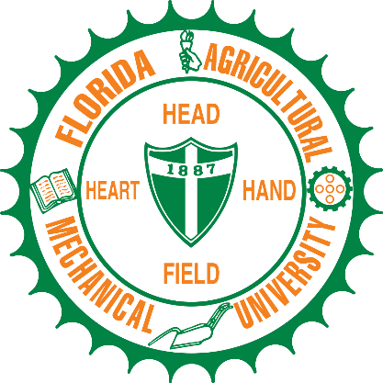

**My website:**

**Don’t forget…**

Many opportunities await you if you do your community service hours. These hours will count toward the Bright Futures Scholarship which is worth up to 2 years of tuition-free school! Who doesn’t like free stuff?? Woohoo!! 😊

How to get your community service hours started:

1. Talk to organizations in your community about helping. This could be a church, an animal shelter, or Teen Court.
2. Get approval for the project from Mr. Howe.
3. Once approved, get the hour sheet from Mr. Howe.
4. Do the hours!

Historical significance of HBCUs

## In a segregated, post-Civil War country, historically black colleges and universities provided black Americans with a quality education. Many well-known and respected artists, politicians, CEOs and political leaders are graduates of the institutions. Today these colleges are still some of the country's top producers of black doctors, scientists and engineers and offer opportunities to a more diverse student body. Around 25% of black doctorate recipients earned a bachelor's degree from an HBCU, according to the National Science Foundation.

Did You Know…

Team Success now offers SAT School Day, which lets you take the SAT at your school on a weekday. You don't register for SAT School Day through College Board. Team Success will offer two free tests to seniors this year. These dates will be announced at a later time. By taking these tests, you may be eligible for fee waivers to take additional tests during regular administrations at weekends.

As a best practice, take the SAT at least twice to give yourself the best chance of standing out to colleges. Talk to Mr. Howe for more info!

Don’t forget to visit my website for more information about colleges universities, colleges and technical institutes. There are also a lot of scholarships available!

**See the QR code above to access all the information about college and career advising!**

Welcome Back!!

Florida Agricultural and Mechanical University won last month’s poll with the majority of 33%!

This University is located in Tallahassee. It is the 5th largest historically black university (HBCU) in the United States by enrollment and the only public historically black university in Florida.

The acceptance rate for FAMU for incoming freshmen is 31%. The graduation rate for first time, full time students is 40% within 6 years.

The university offers 54 bachelor's degrees, 29 master's degrees, one professional degree, and 12 doctoral degrees. It has 12 schools and colleges. Some of the best degrees from this university are pharmaceutical sciences and law.

Notable alumni are Smitty (Rapper) and former mayor of Tallahassee, Andrew Gillum. He also ran for governor!